Feed Search Page Migration to SQL Server
Conversation record, gap analysis, six phase implementation, verification, and screenshot evidence
This document records the Feed Search discussion from the first reported page failure through the discovery-engine investigation, the agreed six-phase plan, and completion of Phases 0 through 6. The final implementation keeps SQL Server Express as the system of record and keeps the optional non-RSS experience detachable from the RSS search path.
Outcome: Feed Search now performs live RSS discovery with query normalization, topic expansion, validation, canonical deduplication, and SQL Server caching. A separately packaged optional discovery panel provides non-RSS results and can be enabled or disabled per user from Settings.

Scope and operating constraints
- All implementation work was restricted to E:\feedom.
- C:\feedometer_next_phase was inspected only as a historical reference for the original Feed Search algorithm. It was not merged or modified.
- SQL Server Express and feedometer_db remain the data system of record. No D1 database was introduced.
- The Cloudflare Worker remains a thin edge integration for existing services. It is not the persistence layer for Feed Search.
- The temporary curated fallback was explicitly treated as removable and was deleted before the new RSS discovery work began.

Conversation timeline
Stage | What was discussed or decided | Result
Initial issue | RSS Reader worked, but Feed Search showed No feeds found for cricket. | Search was isolated as a separate problem.
Provenance question | Existing cards appeared even though the intended product behavior was internet feed discovery. | Curated fallback was identified as temporary and unsuitable.
Reference review | The historical Feed Search engine in C:\feedometer_next_phase was examined without mixing it into E:\feedom. | Strengths and gaps were documented.
Architecture decision | RSS results first; optional non-RSS sources in a detachable popup with six categories. | Six phases were agreed.
Phases 0 to 6 | Fallback removal, SQL foundation, live discovery, plugin backend, popup, preference, and verification. | All six phases completed.

Screenshot evidence
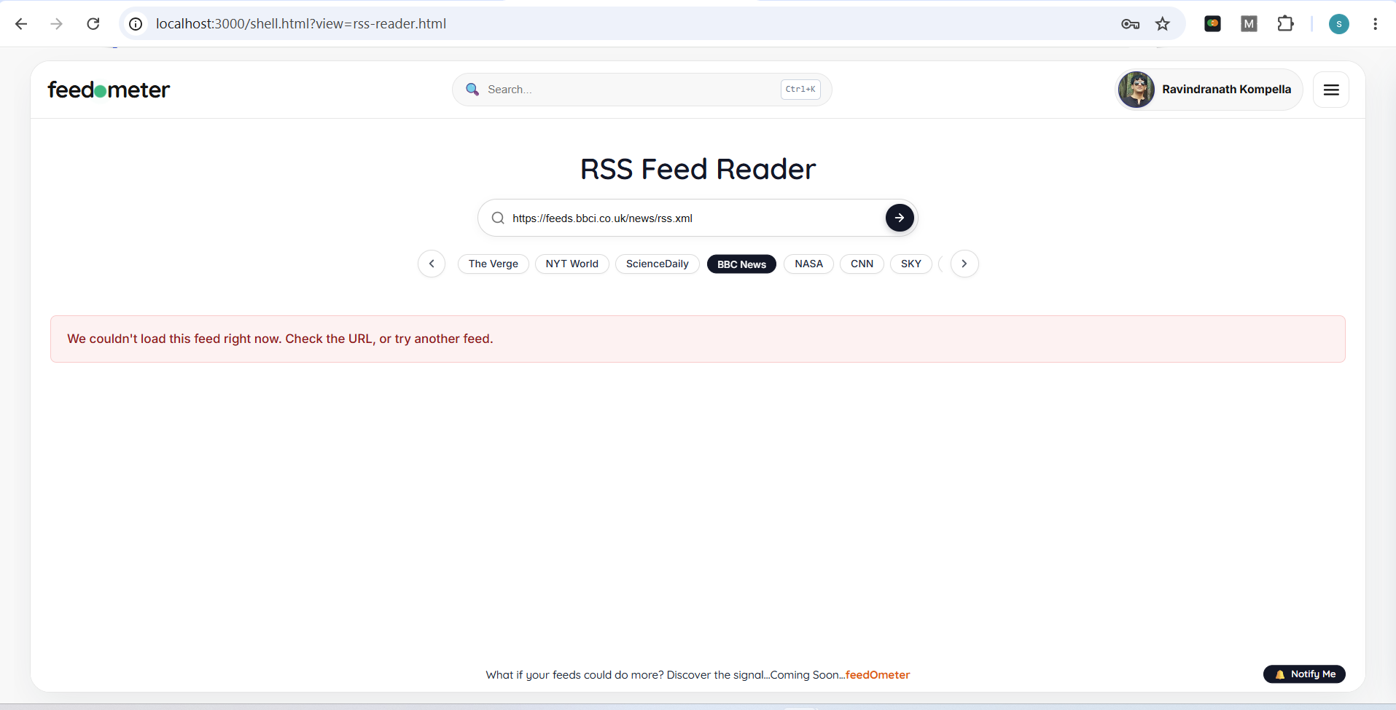
Figure 1. The RSS Reader was working while the Feed Search issue was being isolated.
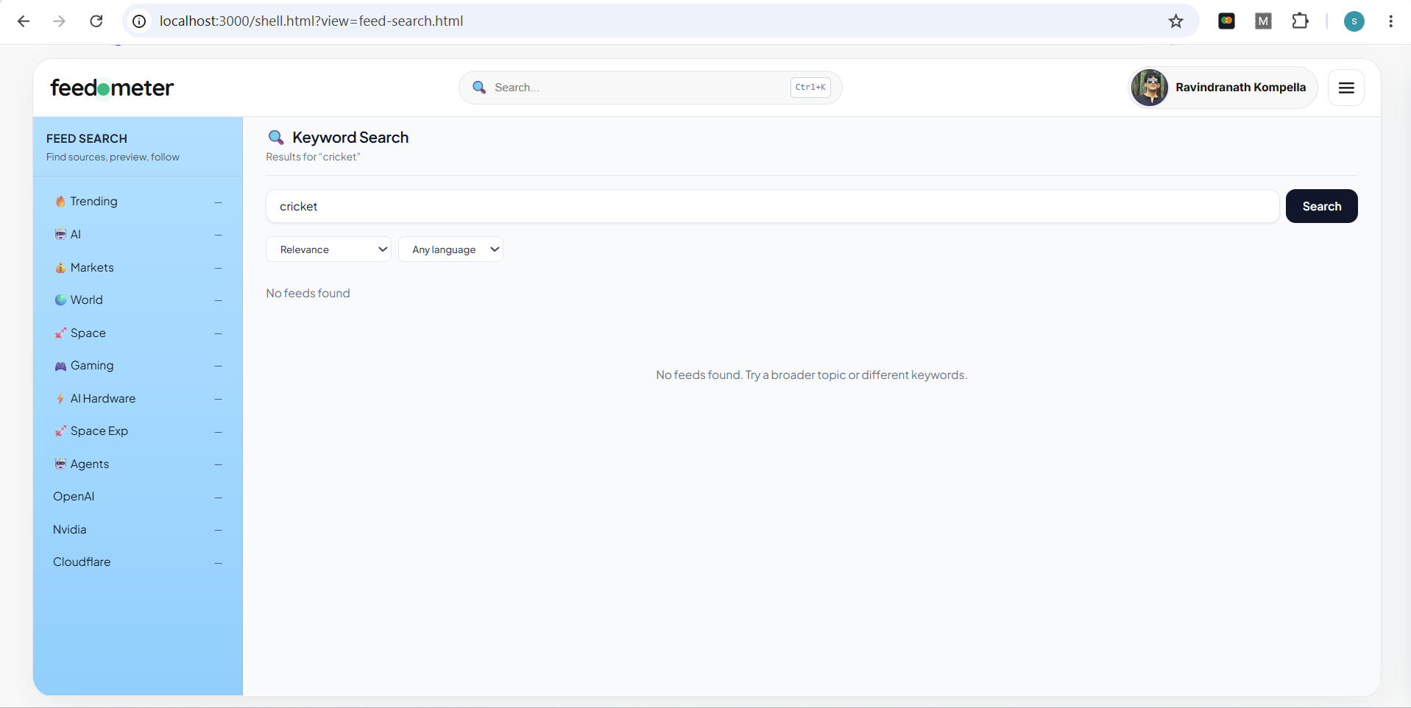
Figure 2. Feed Search returned No feeds found for cricket before the discovery migration.
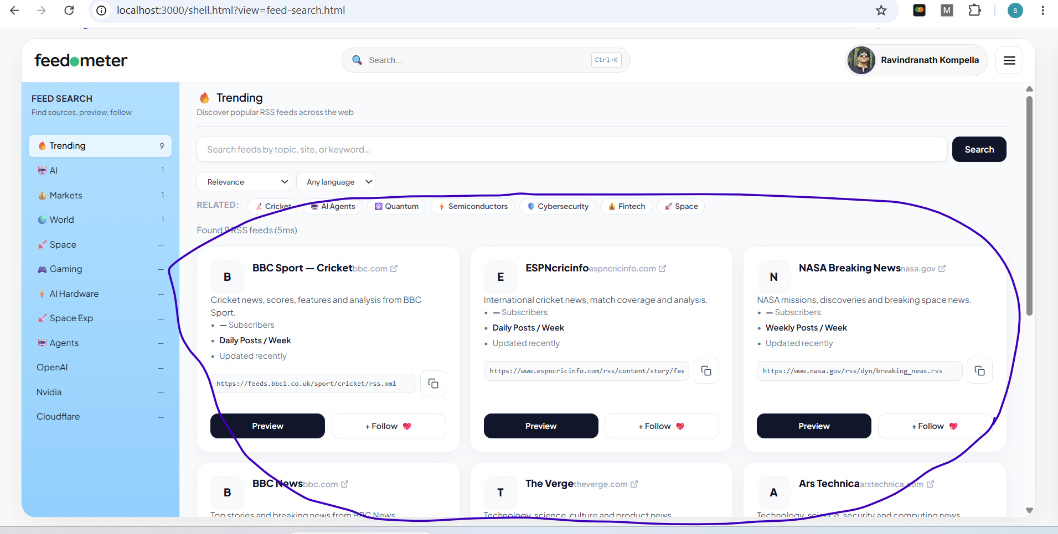
Figure 3. Curated fallback cards that prompted the source and provenance investigation.
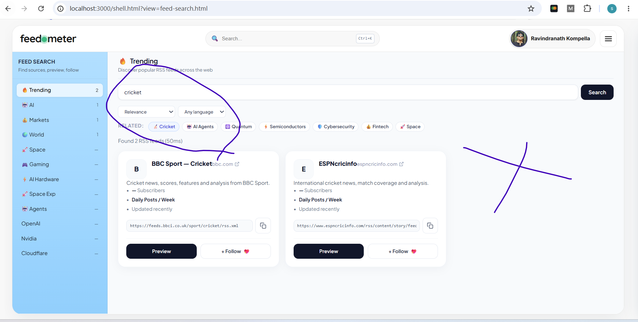
Figure 4. The cricket search result view used to distinguish real discovery from fallback cards.

Initial problem and the questions that changed the direction
User: RSS reader our basic first thing is not working. Please work only on the folder E:\feedom strictly, so that we do not go back to those other Cloudflare accounts using D1. We are using SQL Server.
The RSS Reader was restored first. Immediately after that, the focus moved to Feed Search, which displayed no results for a search such as cricket. The important distinction was that a reader can fetch a known RSS URL, while Feed Search must discover relevant RSS sources from a topic or phrase.
User: When I opened the page I have those cards already. Where from we got those cards. These were supposed to be coming from trending. The search is searching only the data on the page. It is supposed to search internet and bring all the feeds right.
User: We wrote great algorithms to bring data looking at various parameters and checks. Functioning was we can give multiple words such as base ball. Our system would still understand its baseball and gets the details of baseball.
This established two requirements: first, every result needed a clear provenance and storage story; second, query handling had to support multi-word normalization and topic understanding rather than literal string matching alone.

Original engine review in the reference folder
User: Only identify, find the algorithm written there, its strengths and weakness to your proposed solutions above is what you must report. Do not mix our new E:\feedom working directory with that stuff without my approval. Go to C:\feedometer_next_phase and look at the feed search page there, not other search pages.
The historical engine was reviewed only in C:\feedometer_next_phase. The relevant engine was workers/services/feed-discovery-engine.js. It combined Feedly directory search, query variants, a semantic topic graph, provider result scoring, catalog lookups, and result deduplication.
Original strength | Why it mattered | Gap for E:\feedom
Query variants | It could recognize forms such as base ball and baseball. | Needed to be ported without D1 dependencies.
Topic graph | It could expand related interests instead of relying on a single literal phrase. | Needed an isolated SQL-compatible implementation.
Provider aggregation | It could combine live directory results and stored catalog results. | Live result validation and SQL cache ownership needed strengthening.
Scoring and deduplication | It could prioritize and reduce repeated sources. | Canonical URL normalization needed to occur before rendering.
D1-era storage assumptions | It was built around the older worker architecture. | Could not be copied into the SQL Server path.

The reported conclusion was to preserve the algorithmic strengths while replacing the persistence and service boundaries: SQL Server for cache and candidates, E:\feedom Data API for discovery, and no D1 database calls.

Product expansion discussion
User: Can we also add to already available algorithm to make it better you recommended for example Bing Web Search, Google Programmable Search, or Serper, and make our dedup better so that we can dedup and normalize before rendering output.
User: Other than feeds obviously a user would get feeds first on the output page but will have a button saying Other than RSS sources. When user clicks this a popup window will open with all the other result sets for the keywords entered.
The agreed product behavior was RSS first. Non-RSS discovery would remain a separate plugin so it could be turned off or removed later without destabilizing RSS search.
- YouTube channels and relevant recent videos
- Blogs and publisher websites that do not expose an RSS feed
- Recent news articles
- Newsletters/Substacks
- Research papers or institutional sources
- Podcasts, where applicable
User: We are not mixing. I want you to develop this in separate folder and functions and plug it so that in future if we want we can easily turn it off or delete. We will have a setting in our setup page as we progress.

The agreed six phase plan
Phase | Objective | Main deliverable
Phase 0 | Remove the temporary curated fallback. | No fabricated or curated search substitution remains.
Phase 1 | Port query normalization, topic expansion, deduplication, and SQL repository boundaries. | SQL-ready discovery foundation.
Phase 2 | Restore live RSS discovery and validation. | Live, validated RSS/Atom results cached in SQL Server.
Phase 3 | Build the detachable non-RSS discovery backend. | Separate plugin routes, providers, cache, and SQL schema.
Phase 4 | Build the popup interface. | RSS-first page with a lazy-loaded optional other-sources modal.
Phase 5 | Add user choice and feature control. | Per-user SQL Server preference and Settings toggle.
Phase 6 | Verify the complete path. | Smoke tests, schema checks, D1 boundary scan, and launcher check.

The user asked that each phase be completed before a pause, with real-time status updates. Each phase therefore ended with a stated completion status and test evidence.

Phase 0 completion
The temporary FeedDiscoveryService curated fallback was deleted. The Feed Search route was reduced to real SQL-backed source retrieval while the new discovery foundation was prepared. No curated card list remained as a substitute for a search result.
Removed: E:\feedom\data-api\services\FeedDiscoveryService.js
Updated: E:\feedom\data-api\routes\feedRoutes.js

Phase 1 completion
The reference algorithm was ported as an isolated SQL Server compatible discovery layer. This phase established the behavior needed for semantic queries, canonicalization, and cache ownership before adding live providers.
E:\feedom\data-api\discovery\query.js
E:\feedom\data-api\discovery\normalizer.js
E:\feedom\data-api\discovery\topicGraph.js
E:\feedom\data-api\discovery\sqlDiscoveryRepository.js
E:\feedom\data-api\discovery\index.js
- Multiple query variants such as base ball and baseball are normalized before provider lookup.
- Related topic expansion is isolated from the UI and storage layer.
- Feed URLs are canonicalized and deduplicated before results reach the page.
- SQL Server was confirmed connected to localhost\SQLEXPRESS and feedometer_db.

Phase 2 completion
Live RSS discovery was restored through an RSS discovery engine. Feedly is used as a public directory provider, Serper is optional only when a key is configured, and candidate feeds are validated as RSS or Atom before being displayed or cached.
Providers: discovery\providers\feedly.js and discovery\providers\serper.js
Validation: discovery\feedValidator.js
Orchestration: discovery\rssDiscoveryEngine.js
Endpoint: GET /api/feeds/find?q=<query>&limit=<limit>
Tests recorded during the phase included ten validated cricket results, ten base ball/baseball variant results, and successful HTTP output from the local Data API. No fake Serper result was emitted when the Serper key was absent.

Phase 3 completion
The non-RSS capability was implemented as a detachable backend plugin rather than being inserted into the RSS engine. The separate database tables, cache, results, providers, and routes allow the feature to be removed without affecting RSS discovery.
Plugin: E:\feedom\data-api\plugins\other-source-discovery\
Schema: E:\feedom\schema\sql_server_other_source_discovery.sql
Routes: GET /api/discovery/other-sources/types
Routes: GET /api/discovery/other-sources/search?query=<query>&type=<type>
- OpenAlex provides real research and institutional results.
- iTunes provides real podcast results.
- Serper is optional for YouTube, blogs, news, and newsletters. With no key, these categories return no fabricated data.
- The SQL Server tables are dbo.other_source_discovery_cache and dbo.other_source_discovery_results.

Phase 4 completion
The popup client was created in its own frontend folder. Feed Search has only a small custom-event integration: after real RSS results are received, the optional button becomes available. The popup asks for category types only on open, and requests results only for the category selected in the left pane.
Client: E:\feedom\plugins\other-source-discovery\other-source-modal.js
Styles: E:\feedom\plugins\other-source-discovery\other-source-modal.css
Page integration: E:\feedom\feed-search.html
RSS event: feedometer:rss-discovery-complete
The category names returned by the API were checked against the six agreed labels. A live research request returned five results during Phase 4 verification.

Phase 5 completion
A per-user preference was added so the popup can be disabled without disabling RSS search. Existing users and new users default to enabled, preserving the newly available feature. When a signed-in user turns the setting off, the other-sources button remains hidden after RSS results load.
Migration: E:\feedom\schema\sql_server_other_source_preference.sql
Preference column: dbo.user_preferences.other_source_discovery_enabled
Settings checkbox: Show non-RSS discovery sources
Authenticated API: GET and POST /api/auth/preferences
The preference route was confirmed to remain authenticated. An unauthenticated request returned HTTP 401. The Data API was restarted after the migration and reported healthy against feedometer_db.

Phase 6 completion
Verification item | Observed result
Data API health | Healthy on port 8787, connected to feedometer_db.
RSS discovery | Cricket returned five feeds with five unique canonical feed URLs.
Non-RSS sources | Six categories available; research and podcasts returned live results.
SQL tables | feed_discovery_cache, discovered_sources, other_source_discovery_cache, other_source_discovery_results, and the new preference column were present.
D1 boundary | No active D1 database binding or D1 query call found in the Data API, Worker, or detachable plugin.
Launcher | start_feedometer.bat now detects a running API and does not launch a duplicate process.

A Cloudflare D1 phrase remains only as a visible topic label in the Feed Search topic list. It is not an active D1 dependency. The runtime path uses SQL Server Express for persistence.

Current operational state
- The Data API is running locally on port 8787 and is healthy.
- The frontend server on port 3000 was not running at the final verification moment. Running start_feedometer.bat starts the frontend and safely reuses an already-running Data API.
- The optional non-RSS categories that depend on Serper require a configured SERPER_API_KEY. Research and podcast discovery work without it through their live providers.
- No deployment to a different Cloudflare account or D1-backed system was performed as part of this Feed Search work.

Final architecture
The final request path is: Feed Search page -> E:\feedom Data API -> query normalization and topic graph -> SQL catalog/cache plus live RSS directory and validator -> canonical deduplication -> RSS results. If the user has enabled the optional preference, the Other than RSS sources button opens the isolated plugin, which lazy-loads only the selected non-RSS category from its own routes and SQL cache.

File inventory
Area | Representative files
RSS discovery | data-api/discovery/query.js; normalizer.js; topicGraph.js; feedValidator.js; rssDiscoveryEngine.js; sqlDiscoveryRepository.js
RSS route | data-api/routes/feedRoutes.js
Other-source backend | data-api/plugins/other-source-discovery/
Other-source frontend | plugins/other-source-discovery/other-source-modal.js and other-source-modal.css
Settings and preference | settings.html; data-api/services/UserService.js; data-api/routes/authRoutes.js; schema/sql_server_other_source_preference.sql
Startup | start_feedometer.bat

End of Feed Search Page migration record.

